# Steps to Initiate Web Scraping

**0) Configuration of the safari driver**

Prior to Safari automation, enable the Remote Automation feature from the developer menu. To do so, enable the Safari Developer menu first with the steps below:

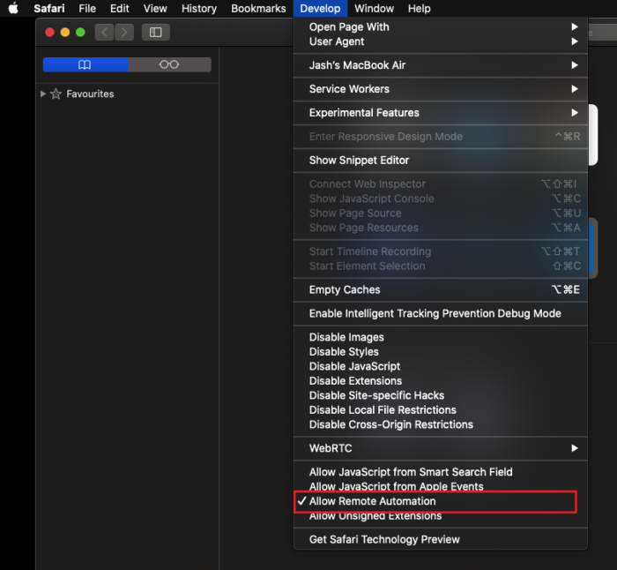

Go to **Safari -> Preferences-> Advanced**

Tick mark the Checkbox with the label – **Show Develop menu** in menu bar

Once done, go to the **Develop menu** and click on the **Allow Remote Automation** option to enable it.

Now we are ready to start the scraping.

# Configurations to Run Web Scraping

1. For the first time ever, execute:
   1. Go to Scripts folder  
        
      
   2. Run command python Setup.py
   3. This will set up all the things required to execute web scraping
   4. This script needs to be executed only once in the lifetime
2. Now, execute main script:
   1. python connection.py
   2. This will open up the following window:

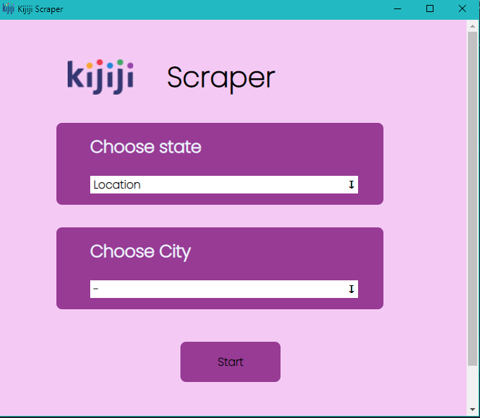

* 1. After Selecting the state, Select the city:

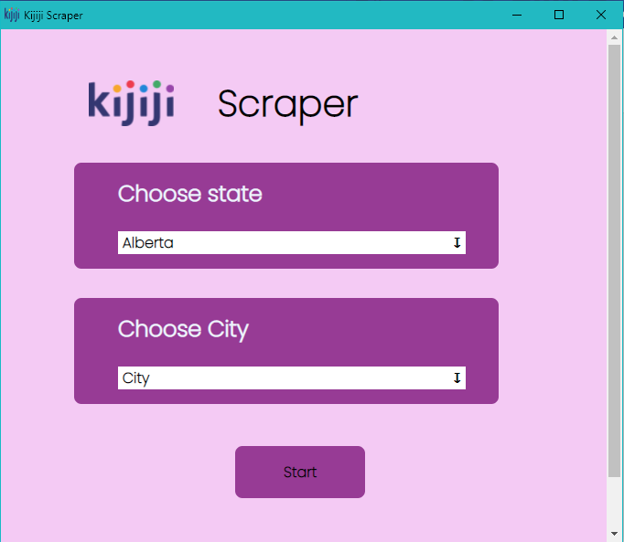

* 1. After Selecting the city, press Start:

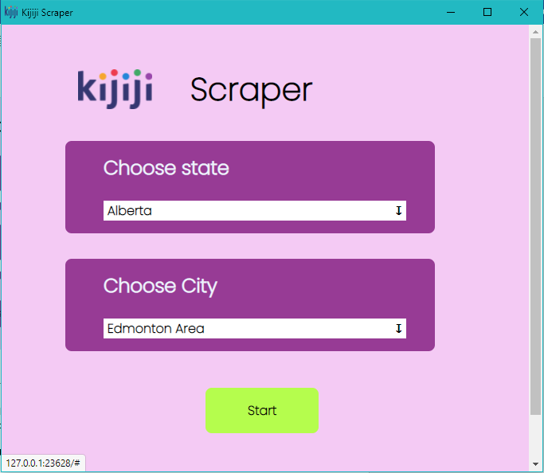

* 1. Now click on Start Button to start the process
  2. This will initiate the process. Wait for the process to be completed.
  3. Check for the Excel file in the Data Folder after completion.